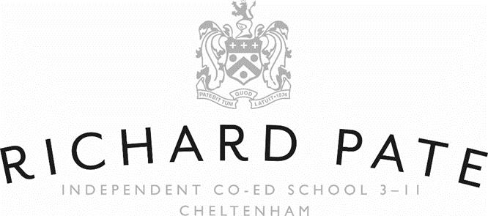

Schedule of Fees (Inclusive of VAT) - With Effect from 1st September 2026
Nursery
5 Mornings £1,769 per term (8.30 a.m. – 12midday)
3 Full days £2,296 per term (8.30 a.m. - 3.30 p.m.)
5 Full days £3,827 per term (8.30 a.m. - 3.30 p.m.)
Additional Sessions
Morning £31 per session (8.30am – 12midday)
Morning with lunch £40 per session (8.30am – 12.30pm)
Full day with lunch £67 per session (8.30am – 3.30pm)
Reception
5 Full Days £4,237 per term (Supervision 8.30am – 4pm)
After School Care (4.00pm – 6.00pm):
4.00pm – 5.30pm - £11 per session, includes a light tea
5.30pm – 6.00pm - £4 per session
Late collection charge after 6.10pm - £15
Breakfast Club (7.45am – 8.30am): £6.50 per session. Includes breakfast and supervised play.
Registration and Assessment Fee / Deposit (Inclusive of VAT): £300*
All fees for the Nursery are exempt from VAT. Early Years Funding is available for each eligible pupil attending the. Nursery (see fees below).
Fees are due on or before the first day of each term.
A full terms’ notice** is required in writing prior to withdrawing a pupil. This means written notice given not later than the final day of the term before the term preceding the term to which the notice relates. For example, a term's notice is required to withdraw your child from the School. So, if you wish to withdraw your child with effect from the start of the Summer Term, a term's notice means you need to tell us in writing about the withdrawal, at the latest, on the last day of the Autumn Term immediately before. This is because the Summer Term is the term to which the notice relates.
*£90 of which relates to a registration fee that is not applicable to “funded-only” children.
** half term’s notice required for fully-funded children

Early Years Funding (Nursery and Reception Fees)
All 3 to 4-year olds are eligible for Early Years Funding (15 hours per week), this is not means tested or requires parents to apply for a code. Early Years Funding can be used on School fees up until (and inclusive of) the term in which a child turns 5 years old. For the Richard Pate School, funding is able to be claimed for 33 weeks of the academic year which is normally between 34 and 35 weeks long.
Estimated Termly Fees for parents eligible for 15 hours of Early Years Funding
Agreed Additional Services Charges:
The Government funding entitlement is for childcare hours that follow the EYFS framework. It does not cover the additional items which we believe greatly enhance the provision at The Richard Pate School and which we know is the reason parents choose our setting. Accordingly, there are agreed optional additional services charges covering the following items:
- Food Charges - Lunches prepared fresh daily in our kitchen and other snacks and drinks.
- Non-food Consumables - such as nappies, wipes, sun cream.
- Activities and Specialist Teaching charges - including: additional materials for physical personalised learning journeys (enhanced from what is required under the EYFS framework), learning equipment / materials and additional art and craft and cookery materials, woodland / forest school sessions in the School’s unique woodland, specialist Music in the main music school, specialist French, PE and Dance in the main School Hall, Games and sports day on the field, productions in the Hall, cookery, Art, topic work activities, parent events, trips, drama productions (all dependent on the day that your child attends). This also includes school readiness activities such as attending full school and pre-prep assemblies, transition days and individual Headteacher assemblies.
- Additional Hours – charged at the relevant rates for Nursery and Reception.
As a result, there are optional additional services charges over and above the funded entitlement to enable pupils to benefit from this enhanced provision. The Government does not encourage parents to opt out of this provision but it is a requirement that parents are able to opt out in which case parents should speak with the Nursery Manager and Head of EYFS or Headteacher so that the appropriate arrangements can be in place.

