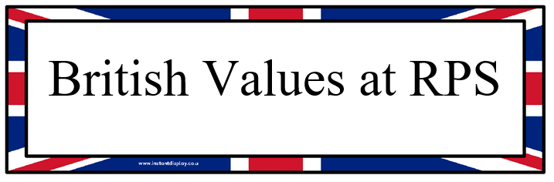
RPS is committed to serving its community, the local area and globally. We recognise the multi-cultural, multi-faith and multi-ethnic nature of both the United Kingdom and our school and seek to promote harmony and the British Values to all.
Democracy: all pupils are involved in the democratic process.
- We have a say in what happens in our school.
- We vote for who represents us on the School Council.
- We elect the School Buddies.
- We help to decide which charities we would like to raise money for by submitting letters for our preferred charity, listening to representative from the Debating Society highlighting why we should vote for the charity and then voting for our favourite charity.
- We help develop school policies including those on behaviour and the aims of our school. An example is our Anti-bullying Policy, this is done annually in our Pupil Voice meetings and is followed up by an assembly and then Junior pupils sign agreed contract in PSHE.

The Rule of Law: our aims, Golden Rules for Children and code of conduct provide a clear ethos and high level of expectations.
Behaviour and rewards are reviewed regularly and Pupil Voice have the opportunity to review the rewards and sanctions.
- We understand how laws are made in Parliament through assemblies, PSHE lessons and history lessons. We also invite the mayor to visit and tell us more!
- We understand the importance of having laws and know that they protect us and influence our behaviour. We discuss this in PSHE, assemblies and Pupil Voice meetings where we contribute to behaviour policies.
- We understand the consequences of breaking laws and rules.
- We help develop fair rules for our class and in school.

Individual Liberty: students are encouraged to make choices within a safe and supportive environment.
Through a range of Pupil Voice and other opportunities, pupils are given freedom to make choices.
Pupils have key roles and responsibilities as School Council reps., members of Pupil Voice groups, Buddies, monitors, librarians and sport ambassadors.
- We can make our own choices in school.
- We know that everyone has rights and responsibilities.
- We know that we need to work within boundaries to make safe choices.
- We know, understand and exercise our rights and personal freedoms safely.
- We have the freedom to make choices about joining extra-curricular clubs.
- We have the freedom to make choices about choosing the level of challenge in some lessons.

Different Faiths and Beliefs: our RE curriculum provides a broad and balanced education on a range of faiths, religions and cultures.
Spiritual, Moral, Social and Cultural education and British Values are taught as both a discreet subject, PSHE and through class teachers, assemblies and curriculum focus days.
- We enjoy learning about different faiths and cultures from around the world.
- We promote diversity through celebrations of different faiths and cultures.
- We know that we are part of a culturally diverse society and have opportunities to experience different cultures.
- We understand how prejudice can lead to hate and how important it is to overcome prejudices.
- Members of different faiths are welcome in our school and are encouraged to share their knowledge with us.
- We enjoy visiting and learning about places of worship from different faiths.
- We use opportunities such as the Olympics and The World Cup to learn about different cultures.

Mutual Respect:
Our PSHE and RE programmes cover the teaching of British Values and mutual respect.
All staff promote an attitude of equality, fairness and respect.
- We know that our behaviour affects our rights and the rights of others.
- We treat each other with respect.
- We work together to help one another.
- We make all visitors feel very welcome in our school.

